

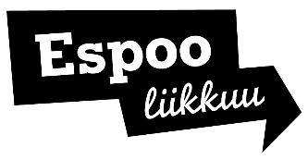

Commitment to ethical guidelines for sports grants and partnerships

Name of club/partner | Enter name
Business ID of club/partner | Enter business ID
Contact person appointed by the club/partner to intervene in harassment and other inappropriate behaviour | Enter contact person’s name
Club’s/partner’s processes and instructions for addressing inappropriate behaviour | Enter the website address where the club’s processes and instructions can be checked

